**KEYLESS PIANO**

By

17BEC1020 SOUBHIK MAZUMDAR

17BEC1066 SAQLAIN AFRID RAHMAN

17BLC1016 HAMID ABDUL RAUF

A project report submitted to

**Dr.B.NAGAJAYANTHI**

**SCHOOL OF ELECTRONICS ENGINEERING**

for CAL in partial fulfillment of the requirements for the course

**ECE2002 – ANALOG ELECTRONICS CIRCUITS**

in

**B.Tech. (ELECTRONICS AND COMMUNICATION ENGINEERING)**



**Vandalur – Kelambakkam Road**

**Chennai – 600127**

**FALL SEMESTER – 2018-19**

**NOVEMBER 2018**

**TABLE OF CONTENTS**

1. Bonafide certificate---------------------------------------------------------- Page No.

2. Abstract--------------------------------------------------------------------------------- 4

3. Acknowledgment---------------------------------------------------------------------- 5

4. Objective of the project--------------------------------------------------------------- 6

5. Component requirements and Estimation------------------------------------------ 7

6. Component Description-------------------------------------------------------------- 8

7. Schematic of the circuit------------------------------------------------------------- 9

8. Implementation -----------------------------------------------------------------------10

9. Sequential Explanation of Implementation -------------------------------------- 11

11. Results and Observations----------------------------------------------------------12

12. Snapshots with working -----------------------------------------------------------13

13. Conclusion-------------------------------------------------------------------------- 14

14. Reference ----------------------------------------------------------------------------15

**BONAFIDE CERTIFICATE**

Certified that this project report entitled “**KEYLESS PIANO”** is a bonafide work of **SOUBHIK MAZUMDAR (17BEC1020), SAQLAIN A RAHMAN (17BEC1066)** and **HAMID ABDUL RAUF (17BLC1016)** carried out the “J”-Project work under my supervision and guidance for ECE 2002 ANALOG ELECTRONIC CIRCUITS.

**Dr.B.NAGAJAYANTHI**

School of Electronics Engineering (SENSE),

VIT University, Chennai

Chennai – 600 127.

**ABSTRACT**

In this project we have eliminated the need of buttons involved to play the piano. Here we have used IR in place of buttons. The push buttons have been replaced by IR sensor module in this project.

This module is capable of sensing any obstruction caused in its IR beam path. This obstruction forces the module to change the output voltage level in output.

In our case fingers will be obstructing the IR beam which in turn will produce a voltage level change. As a result, it acts same way as a button press. This way we can simulate the key press by obstructing the beam path.

Each notes in a piano will have certain frequency values. By creating those frequency signals, we can produce tones identical to the piano.

**ACKNOWLEDGEMENT**

We wish to express our sincere thanks and deep sense of gratitude to our project guide, **Dr.B.NAGAJAYANTHI,** School of Electronics Engineering, for her consistent encouragement and valuable guidance offered to us in a pleasant manner throughout the course of the project work.

We are extremely grateful to **Dr. Sreedevi.V.T,** Dean of the Schools of Electrical Engineering (SELECT) and Electronics Engineering (SENSE), VIT University Chennai, for extending the facilities of the School towards our project and for her unstinting support.

We express our thanks to our Programme Chair **Dr. Menaka (for B.Tech-ECE)** for her support throughout the course of this project.

We also take this opportunity to thank all the faculty of the School for their support and their wisdom imparted to us throughout the course.

We thank our parents, family, and friends for bearing with us throughout the course of our project and for the opportunity they provided us in undergoing this course in such a prestigious institution.

**Objective of the Project**

To make a Keyless Piano works based on Infrared Light sensor. Instead of old type keyboards which has keys, by pressing we get a particular type of sound which is a signal. Here we replaced key with an IR sensor and the signal is generated from a signal generator app which is amplified using an amplifier circuit. The IR sensor and speaker is connected using relay, works such that if finger detected by sensor it will turn ON the speaker.

**Component Requirement and Estimation**

|  |  |  |  |
| --- | --- | --- | --- |
| **S.No** | **Component Name** | **Quantity** | **Cost (in Rs.)** |
|  | **Breadboard** | **1** | **90** |
|  | **Speaker** | **1** | **80** |
| **3.** | **TIP31,TIP32** | **1 each** | **30** |
| **4.** | **BC547** | **1** | **5** |
| **5.** | **LM358** | **1** | **15** |
| **6.** | **Diodes** | **5** | **7** |
| **7.** | **Capacitor(10uF)** | **1** | **3** |
| **8.** | **Resistors** | **4** | **5** |
| **9.** | **Transformer** | **1** | **150** |
| **10.** | **IR sensors** | **1** | **160** |
|  | **Total** |  | **545** |

**Overall Cost of the project: Rs. 545**

**Component Description**

**1. Dual Power Supply**

A general-purpose step-down transformer (12-0-12) has to wires for input 220 volts AC voltage and three wire output in which two provides 12V AC 180° out pf phase and remaining one is ground. A full bridge rectifier is used to convert AC signal to DC. Here we are using it to convert AC power supply to DC supply. Connecting two 12V AC output from transformer across full bridge rectifier, we get +12V and -12V DC output across other ends with respect to ground. Now this power supply will be supplied to the remaining circuit.

**2. Small Signal Amplifier**

LM358 is used for the small signal amplification.  LM358 is a low power dual operational amplifier integrated circuit. It is designed for general use as amplifiers, high-pass filters, low band pass filters, and analog adders. The typical supply current is 500uA independent of the supply voltage range and a maximum current of 700uA, Operating ambient temperature – 0˚C to 70˚C.

**3. Power Amplifier**

A class ‘B’ power amplifier is used here. It is a type of power amplifier where the active device conducts only for one half cycle of the input signal. That means the conduction angle is 180°. Since the active device is switched off for half the input cycle, the active device dissipates less power and hence the efficiency is improved.

**5. Relay as a switch**

The advantage of relays is that it takes a relatively small amount of power to operate the relay coil.

**7. Infrared Sensor**

In Infrared Sensor the emitter is simply an IR LED and the detector is simply an IR photodiode which is sensitive to IR light of the same wavelength as that emitted by the IR LED. When the IR receiver does not receive a signal, the potential at the inverting input goes higher than that non-inverting input, when the IR receiver module receives signal to the potential at the inverting input goes low.

**Schematic of the circuit**

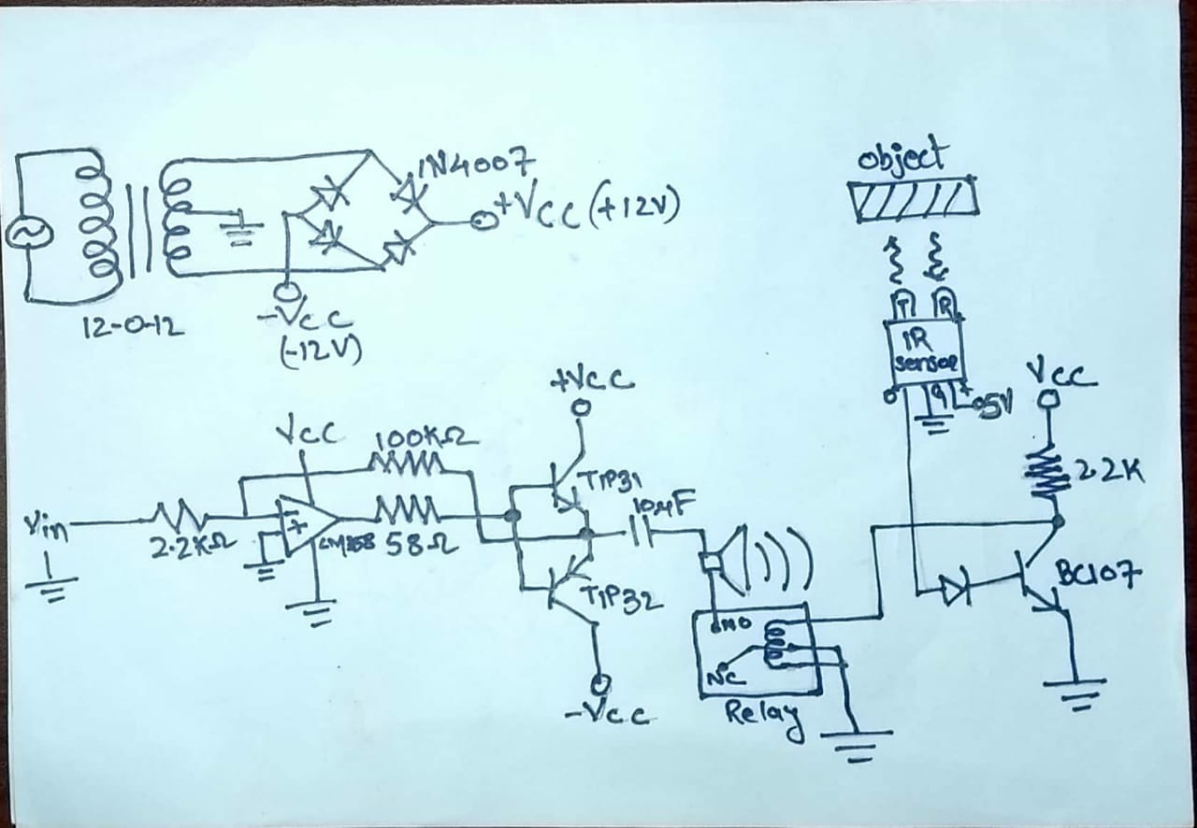

**Implementation**

The main features of the basic block diagram (given below) are

* Dual power supply
* Small signal amplifier
* Power amplifier
* Speaker as signal output
* Relay as a switch
* Not gate using BJT
* Infrared Sensor

**Sequential Explanation of Implementation**

A continuous sinusoidal signal of a particular frequency is taken as Vin to circuit, here we are using a mobile app to input such a signal. Then this small signal is amplified using an Op Amp LM358. Vin is given to inverting input of op amp i.e. pin 2. Pin 3 i.e. non-inverting input is grounded. Vcc and ground is given to IC. Output is taken from pin 1 of LM358 and feed to class B power amplifier to amplify the signal such that it can run a speaker. A feedback resistor of 100k is connected to output of class B amplifier and input source which will help to increase the gain.

The connection of speaker to ground is broken using a relay. Normally open terminal of relay connected to ground of speaker, the common terminal of relay is connected to common ground and the normally close terminal of relay is connected to nowhere. One end of coil of relay is grounded and the other end is input signal from IR sensor. As we know IR sensor has output signal of >2V when there is no object in vicinity to it and 0V when there is. And since the coil of relay needs > 9V to operate we used a BJT based NOT gate configuration.

The output of IR sensor is given to base of BJT (BC107B) and the output from BJT i.e. from collector is taken as input to coil of relay. So, whenever there is object in vicinity to sensor it provides zero current to base and the BJT restricts the flow of current from collector to emitter and provides DC output signal to relay (and vice versa). Switching ON the coil connects the common of relay to normally open pin of relay and hence completing the continuity. This provides common ground connection to speaker and the speaker gives audio output from amplified input sinusoidal signal with respect to ground.

**RESULT AND OBSERVATION**

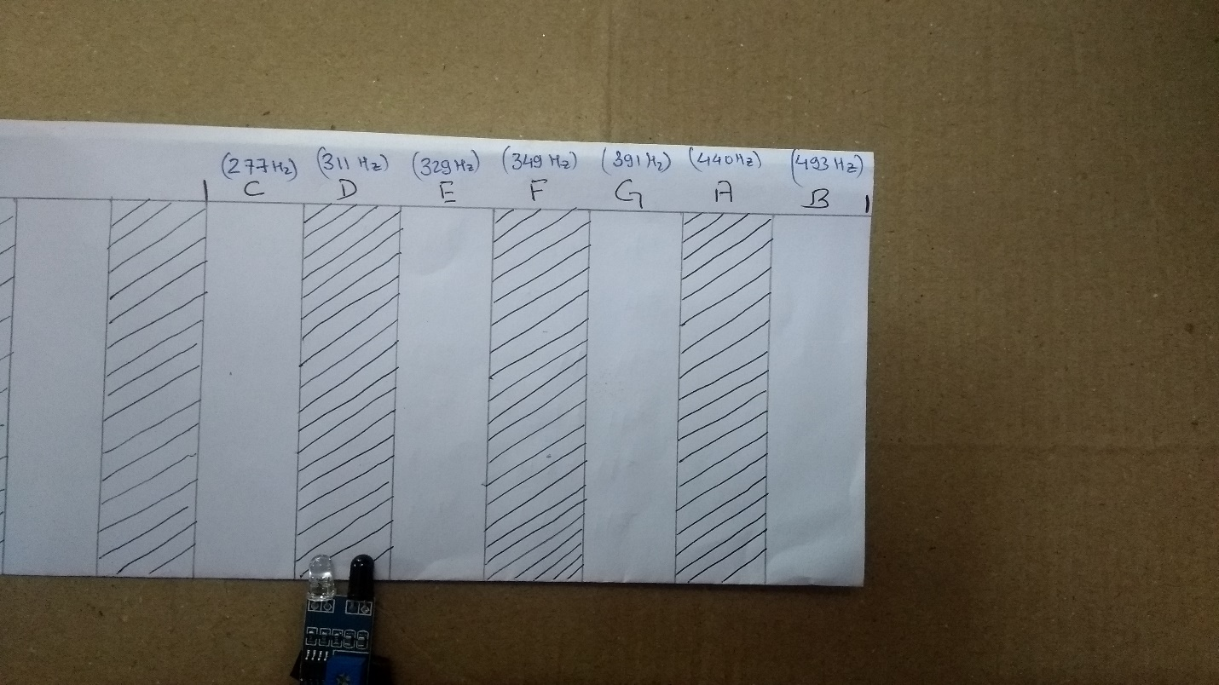

As shown in figure for different notes input signal is changed to different frequency. In original keyboard we will be using 7 IR sensors for 7 note keyboard. Since this is a demo we are using only one sensor.

So as we see sensor is placed on “D” note, as we press that virtual key we get an sound of 311Hz from speaker. Similarly if we place it on “A” note : first we change the input frequency to 440Hz then use it. We get a sound of 440Hz by pressing A.

**SNAPSHOTS**

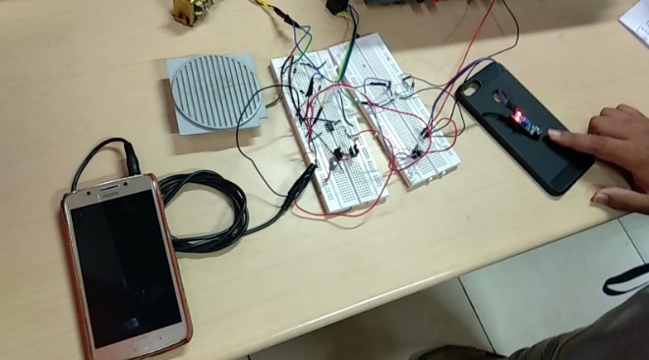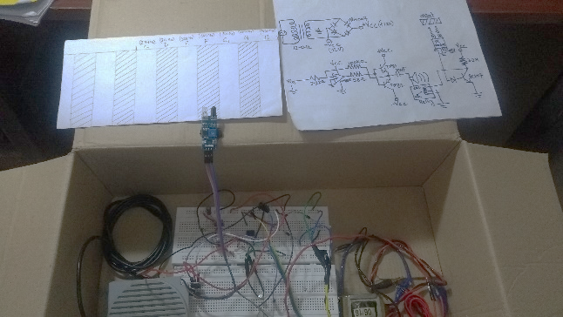

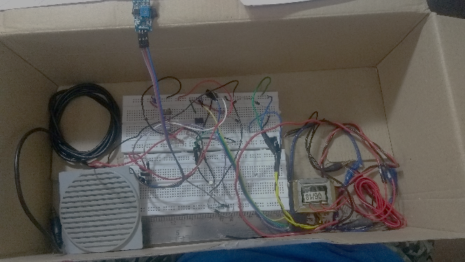



**CONCLUSION**

We made keyless piano according to our design. If this design is followed we can make 52 virtual keyed piano. For this 52 key we might need 52 IR sensor and 52 different frequencies. Now for this we may need a frequency generator in circuit or a frequency storage device which stores 52 different frequencies. This frequencies get played when there is demand from IR sensors. This is a futuristic technology which can be used as modern day musical instrument.

**REFERENCE**

- Microelectronics, Circuit Analysis and Design by Donald A. Neamen, 4th edition

- <https://www.electronics-tutorials.ws/opamp/opamp_1.html>